# Weekly Report – 26 Feb 2018

## PWM Generation using DSP

### Digital Input / Output

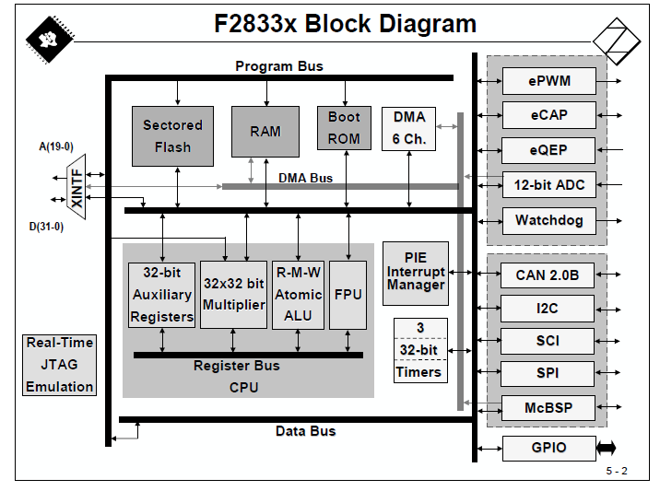

Figure 1: General Block Diagram of uP

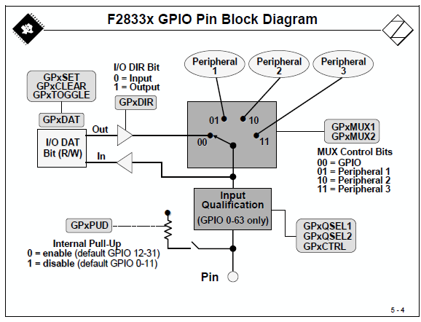

Figure 2: GPIO Pin Block Diagram

### Interrupts

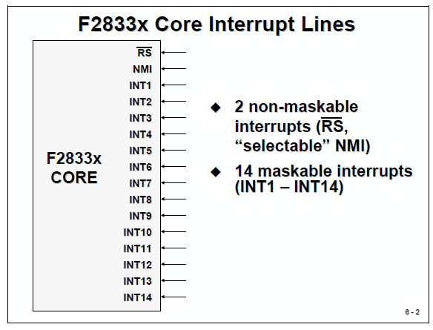

Figure 3: Interrupt Lines

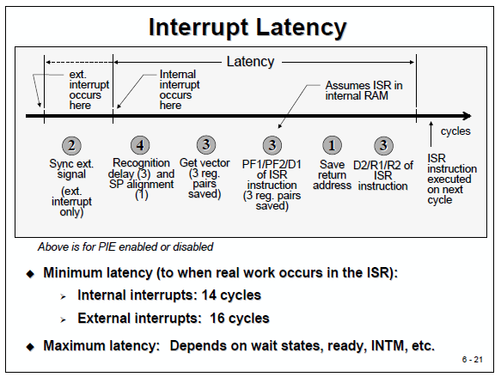

Figure 4: Interrupt Loop

### PWM Generation

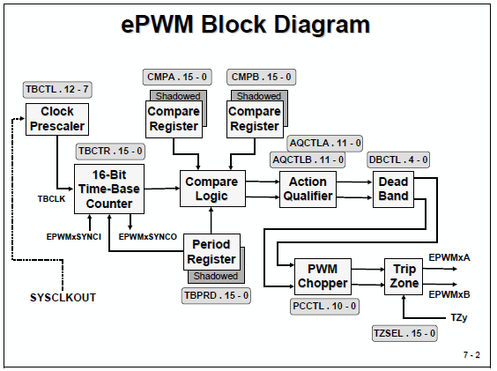

Figure 5: ePWM Block Diagram

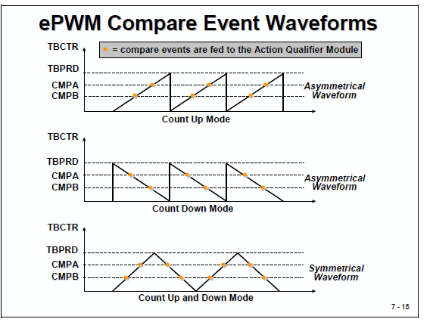

Figure 6: Timer Counter Modes

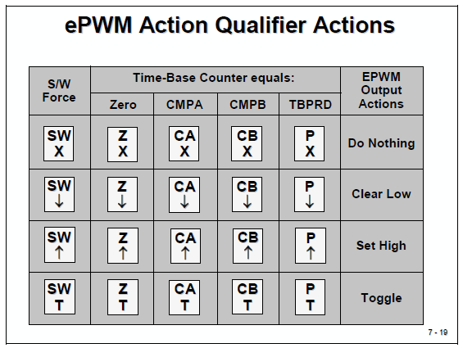

Figure 7: Action Qualifier

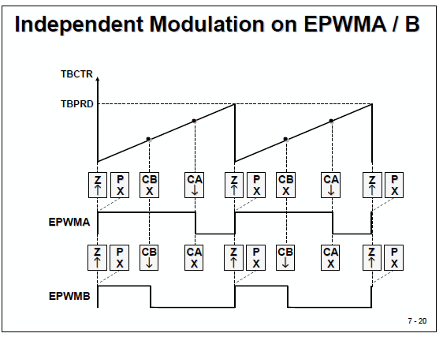

Figure 8: How action qualifier works

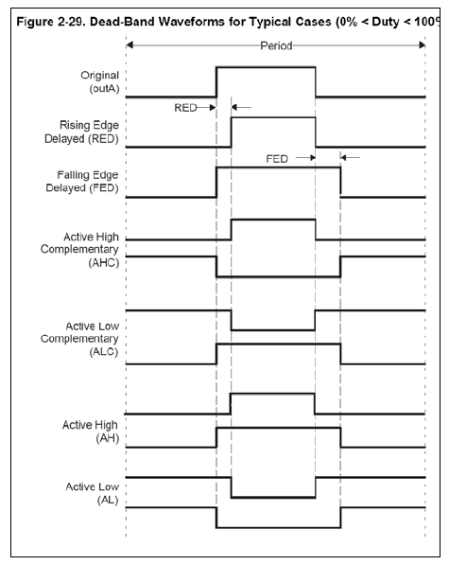

Figure 9: Dead Time

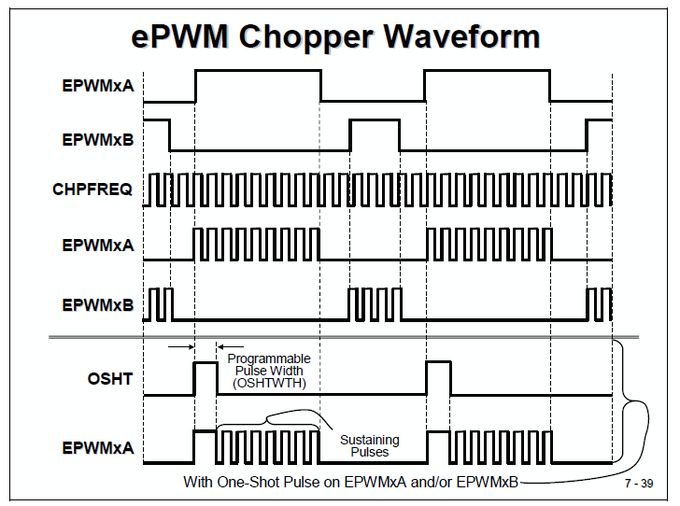

Figure 10: PWM Chopper

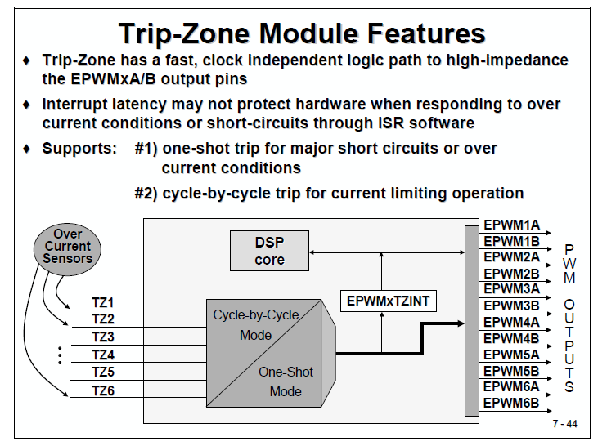

Figure 11: Trip Zone

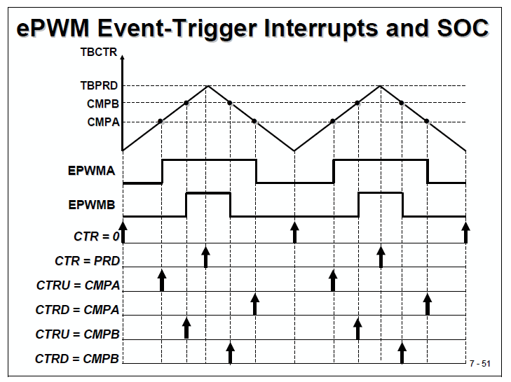

Figure 12: ePWM Interrupt